Healthy Sausage Rolls
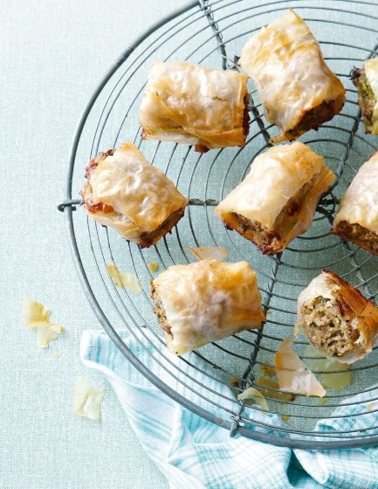 £3 for 12
150g good quality sausage meat
150g British pork mince
100g ready-cooked quinoa
1 tbsp English mustard
1 small shallot, finely chopped
Bunch of fresh parsley, chopped
5-6 fresh sage leaves, chopped
1 medium free-range egg, beaten
3 large filo pastry sheets
25g butter, melted

- Preheat the oven to 200°C/fan180°C/gas 6. Mix all the ingredients, except the filo and butter, in a bowl with some seasoning. Fry a little of the mix to taste, then season again if needed.
- Lay a sheet of filo pastry on the work surface, brush with a little butter, then place another sheet on top. Brush over a little more butter, then lay the final sheet on top. Cut lengthways to give 2 rectangular strips. Spoon half the sausage mixture along a long edge of one of the pastry strips, moulding the mixture into a sausage shape with your hands as you go. Repeat with the rest of the mixture on the other pastry strip. Brush the exposed pastry with a little of the remaining butter, then roll up, enclosing the sausagemeat. Brush all over with more butter, then slice into 5cm sausage rolls.
- Put the rolls on a lined baking sheet, keeping the pastry join underneath, then transfer to the oven and cook for 20-25 minutes until the pastry is golden and the sausagemeat is cooked through

